**Review Worksheet Answers: Intro to Biotechnology / PCR**

1: What is biotechnology?

(1 mark)

*Biotechnology is the use of technology to manipulate organisms for human advantage. (1)*

2: Give three examples of modern biotechnological techniques.

(3 marks)

*Any three of:*

* *Genetic Testing*
* *Gene Manipulation*
* *Cell Replacement Therapies*
* *Tissue engineering*

3: What is the Human Genome Project, and what are some potential benefits?

(4 marks)

*The Human Genome Project is the mapping of the base sequence of the entire human genome. (1)*

*Potential benefits include*

* *Finding the location of faulty genes on chromosomes for diagnosis and/or replacement. (1)*
* *Monitoring gene expression to find out more about pathways of genetic disease. (1)*
* *Genetic testing for disease risk, for complex diseases with multiple genes involved. (1)*

4: What is the overall purpose of Polymerase Chain Reaction (PCR)?

(2 marks)

*The purpose of PCR is to quickly (0.5) make many copies of a sample of DNA (0.5) so that it can be used in other biotechnological processes.*

5: What are the main ingredients in the PCR process and what does each do?

(4 marks)

* *The DNA strand to be copied (1)*
* *Primers (0.5) as starting points for attachment of free nucleotides (0.5)*
* *Free nucleotides (0.5) to bind to the template strand to create the complementary strand (0.5)*
* *Taq polymerase (0.5) to bind the nucleotides to the template strand (0.5)*

6: Describe in detail the steps in the PCR process.

(10 marks)

*1: Denaturation (0.5) at 96oC (0.5): Heat separates the DNA strands (0.5) to provide single stranded templates (0.5).*

*2: Annealing (0.5) at 55-65oC (0.5): The reaction is cooled (0.5) so the primers can anneal (bind) (0.5) to the template DNA (0.5 )to create a starting point for nucleotides to be added (0.5).*

*3: Extension (0.5) at 72oC (0.5): The temperature is raised (0.5) so that Taq polymerase can add new nucleotides (0.5) to the primer (0.5), extending the complementary strand (0.5).*

*The cycle of heating and cooling is repeated 25 to 35 times (0.5) over a period of several hours*

*(0.5). Each cycle the process doubles the number of copies of the original sample (0.5) to produce*

*millions of copies (0.5).*

7: Why can’t human DNA polymerase be used in the PCR process?

(3 marks)

*PCR involves heating the sample up to high temperatures (1) to separate the DNA strands. Human DNA polymerase also denatures during this process (1) so can’t be used for repeated cycles (1).*

8: What is the origin of *Taq* polymerase and why can it be used successfully in PCR?

(3 marks)

*Taq polymerase is the type of DNA polymerase (0.5) found in the bacterium (0.5)* Thermus aquaticus (0.5)*. This bacterium naturally occurs in the very hot water (0.5) near geothermal vents (0.5), so its DNA polymerase is resistant to denaturing at high temperatures (0.5), and therefore can be used through many PCR cycles (0.5).*

9: What do you think the water temperature would be near the geothermal vents where *Thermus aquaticus* lives? Explain your answer.*

(3 marks)

*The temperature of the water would be around 72oC (1). The PCR mixture is heated to this temperature (0.5) so that the Taq polymerase can attach the free nucleotides to the template strand (0.5). It can be inferred that Taq polymerase is adapted to work best at this temperature (0.5), and therefore that it is the temperature of the water where T. aquaticus lives (0.5).*

10: Which part of the PCR process is indicated by each letter on the diagram shown?

(4 marks)

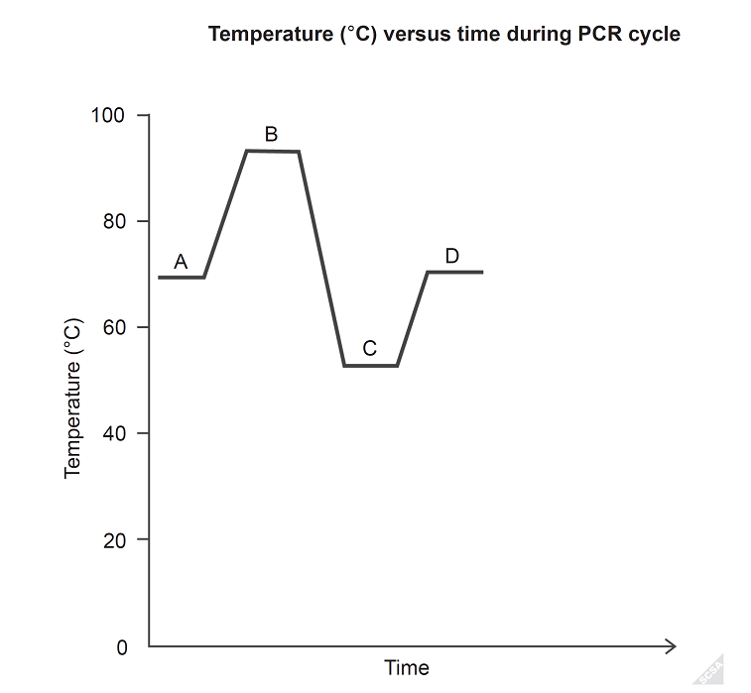

*A: Extension/strand synthesis*

*B: Denaturation*

*C: Primer Annealing*

*D: Extension/strand synthesis*

11: List applications of PCR.

(4 marks)

*PCR makes many copies of DNA for:*

*Forensic identification using gel electrophoresis*

*Cloning to use in recombinant DNA technology*

*Sequencing of DNA to identify genetic diseases*

*To test for presence of bacterial or viral DNA/RNA to diagnose infection*



12: List the principles of evolution by natural selection.

(6 marks)

*1: There is variation of characteristics within a species.*

*2: More offspring of a species are produced than can survive to maturity.*

*3: High birthrate and limited resources lead to a struggle for existence – competition*

*for survival.*

*4: Individuals with characteristics best suited to the environment have more chance*

*of surviving and reproducing – survival of the fittest.*

*5: Favourable characteristics (those with survival value) are passed on to the next*

*generation.*

*6: In the gene pool, the proportion of alleles that produce favourable characteristics*

*gradually increases.*